**Domain Information/ Knowledge:**

**Supply Chain:**

A supply chain is a complex logistics system that consists of facilities that convert raw materials into finished products which are later distributed to end-consumers.

**Supply Chain Management:**

Supply chain management is the handling of the entire production flow of a good or service — starting from the raw components all the way to delivering the final product to the consumer. A company creates a network of suppliers (“links” in the chain) that move the product along from the suppliers of raw materials to those organizations that deal directly with users.

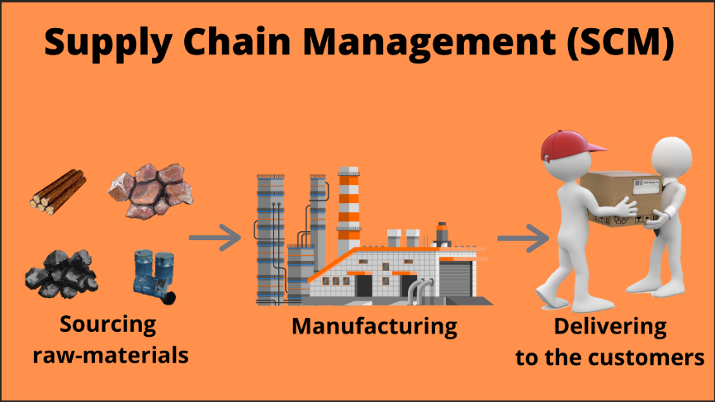

**How does Supply Chain Management work:**

According to CIO, there are five components of traditional supply chain management systems:

* **Planning:** Plan and manage all resources required to meet customer demand for a company’s product or service. When the supply chain is established, determine metrics to measure whether the supply chain is efficient, effective, delivers value to customers and meets company goals.
* **Sourcing:** Choose suppliers to provide the goods and services needed to create the product. Then, establish processes to monitor and manage supplier relationships. Key processes include: ordering, receiving, managing inventory and authorizing supplier payments.
* **Manufacturing:** Organize the activities required to accept raw materials, manufacture the product, test for quality, package for shipping and schedule for delivery.
* **Delivery and Logistics:** Coordinate customer orders, schedule deliveries, dispatch loads, invoice customers and receive payments.
* **Returning:** Create a network or process to take back defective, excess or unwanted products.

**Why Supply Chain Management System Important:**

Supply chain management chain is important because:

* **Identifying potential problems:**When a customer orders more product than the manufacturer can deliver, the buyer can complain of poor service. Through data analysis, manufacturers may be able to anticipate the shortage before the buyer is disappointed.
* **Optimizing price dynamically:** Seasonal products have a limited shelf life. At the end of the season, these products are typically scrapped or sold at deep discounts. Airlines, hotels and others with perishable “products” typically adjust prices dynamically to meet demand. By using analytic software, similar forecasting techniques can improve margins, even for hard goods.
* **Improving the allocation of “available to promise” inventory:**Analytical software tools help to dynamically allocate resources and schedule work based on the sales forecast, actual orders and promised delivery of raw materials. Manufacturers can confirm a product delivery date when the order is placed — significantly reducing incorrectly-filled orders.

**Important Matrix for Supply Chain Analysis:**

1. **Orders:** Unique request placed by customers.
2. **Order lines:**

Within an order, a customer could request multiple items. Each of these items requested within the order is called an order line. (Unique order_id is order line)

**Order lines** = Count the order lines.

**Example:**

Let's say you order 4 notebooks and 2 pens at Amazon. A unique order ID is generated for all these items. Notebook and Pen is an order line.

1. **LIFR (Line Fill Rate):**

Line Fill Rate is an important metric for the supply planning team to understand how many lines they shipped in full out of the total lines ordered. This metric does not consider the delivery time of the order.

**LIFR** = (lines fulfilled or shifted) / (total lines ordered)

**Example:**

Let's say you order 4 notebooks and 2 pens at Amazon and Amazon is able to ship you 4 notebooks and 1 pen. The line-item pen is failed because you requested 2 no. So, Line Fill Rate for Amazon for your order is order lines fulfilled / lines ordered => 1/2 => 50 %

1. **VOFR (Volume Fill Rate):**

Volume fill rate or case fill rate is a similar metric useful for the supply planning team to understand the total quantity they are able to ship for a customer per order or for a given period of time.

**VOFR** = (total quantity shifted) / (total quantity ordered)

**Example:**

Suppose, you ordered mobile 35 quantities and 11 quantities are shifted. So, volume fill rate will be 11/35 = 31%

1. **OT % (On Time Delivery %):**

It determines if an order is delivered as per the agreed time with the customer. This metric is important for the warehouse & distribution team.

It simply determines, how many percentages of orders are delivered **ON Time.**

**OT %** = (no. of orders delivered on time) / (total no. of orders)

1. **IF % (In Full Delivery %):**

It determines if an order is delivered in full as per the requested quantity by the customer.

It simply determines, how many percentages of orders are delivered as per requested quantity by customers.

**IF %** = (no. of orders delivered in full quantity) / (total no. of orders)

1. **OTIF % (On Time In Full Delivery %):**

It determines if an order is delivered BOTH in full and On Time as per the customer order request. This is a hard metric which measures the reliability of an order from customer's point of view.

It simply determines, how many percentages of orders are delivered in full and on time as per customer request.

**OTIF %** = (no. of orders delivered on time in full quantity) / (total no. of orders)

1. **Cash-to-Cash Cycle Time (Cash-Flow):**

This metric tells you the length of time between when you pay suppliers for materials and when customers pay for the final finished product. You want the cycle time to be as short as possible.

Tracking this metric will help identify potential causes of cash flow issues. The most efficient companies have cash-to-cash cycle times of less than one month.

**Cash-to-cash cycle time** = receivable days + inventory days – payable days

1. **Customer Order Cycle Time (COCT):**

Customer order cycle time tracks the number of days between your company receiving a purchase order and completing customer delivery.

It helps measure the responsiveness of your supply chain and how well you’re providing customer service.

It simply means, how many days take to delivery the products when products were placed or ordered.

**Customer Order Cycle Time (COCT)** = (actual delivery date) – (purchase order creation date)

1. **Service Rate:**

The service rate measures the percentage of product orders that are delivered on time.

**Example:** Suppose, I placed an order of 25 books to FlipKart, FlipKart received this orders, and 10 products delivered **on time**. Then service rate will be: (10/25) * 100 = 40%.

**Service rate** = product orders delivered on time / product orders received

1. **Perfect Order Index or Perfect Order Delivery Rate:**

The perfect order index measures the percentage of your orders that are error-free from beginning to end.

That means the order was recorded correctly, shipped on time and in the right quantities and arrived without damage.

Errors means the orders are not recorded correctly, not shifted on time, not shifted in full quantity, damage orders (basically products) and not shifted on time in full quantity, etc.

**Perfect order** = [(total orders – errors) / total orders] x 100

1. **Damage Free Delivery:**

The percentage of orders that are delivered without any damages.

**Damage Free delivery** = [(total orders – orders that arrive damaged) / total orders] x 100

1. **Accurately Documented Order:**

Percentage of orders in which all documents relating to the order are accurate.

**Accurately documented order** = [(total orders – orders without accurate documentation) / total orders] x 100

1. **Delivery Delay %:**

How much time take to delivery of a particular products from promised delivery date.

**Delivery Delay %** = (Actual Delivery Date) – (Promised Delivery Date)

1. **Freight Cost Per Unit:**

Freight cost per unit measures how economically you ship your products. It measures your total freight costs divided by how many units you’ve shipped. You can calculate units in pounds, items or any other measurement that makes sense.

**Freight cost per unit** = (total freight cost) / (number of units)